ART EXHIBITION SEPTEMBER 27TH and 28TH 2025
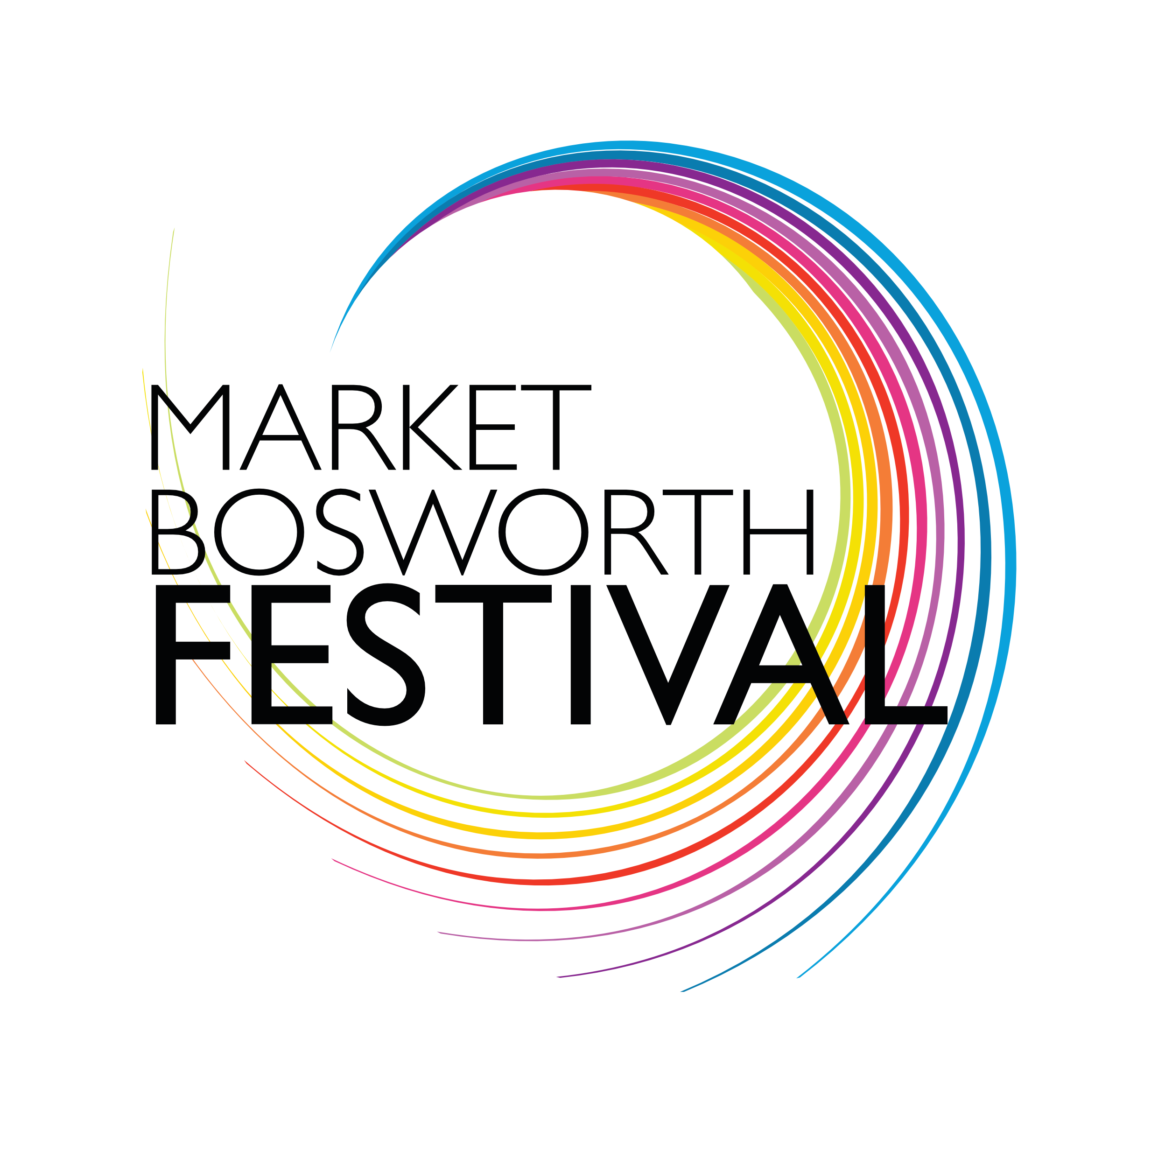
Enquiries / entry forms to: artexbooking@gmail.com
Tel: 07890 002127

Submissions are invited for an open art exhibition as part of the Market Bosworth Festival 2025

DEADLINE for entry forms - 29th August 2025

DELIVERY to Dixie Grammar School Hall, Station Road, CV13 0LE
- on Friday 26th September 5.30pm to 6.30pm

Each artist can submit up to THREE pieces of work.

- Wall hung 2D or 3D works in any media (including photography) – must be strung and ready to hang.
- Art work should not have been submitted to this exhibition in previous years.
  - Prints must be limited editions and framed.
  - Wall hung work should be no more than one metre in any dimension and not excessively heavy.
  - 2D work on paper must be framed with the frame and mount of good saleable condition.
  - 2D work on canvas may be unframed.
  - Work in clip frames cannot be accepted.
  - Labelling: Each piece to be clearly identified and priced. Labels to be on the reverse.
  - 10% commission on all sales

Unsold work must be collected between 4.15 and 5pm on SUNDAY 28th September

Please fill in the details requested below on Page 2.

Email to artexbooking@gmail.com or post with your cheque to the address shown on page 2.

ART EXHIBITION 2025 : ENTRY DETAILS – PLEASE FILL IN

Name

Address
Telephone numbers  (mobile for on the day) | MOBILE |  |  | HOME
EMAIL Address
(essential)
Entry Fee  ENTRY FEE £3  per picture  + 10% commission on sales | Bank transfer  (preferred)  Market Bosworth Festival Ltd  Acc: 81420607  Sort code: 40-32-03  Ref:  Your Surname-Art | Tick | Or Cheque to  Market Bosworth Festival Ltd.  Post to :  Moore’s Cottage  Bosworth Rd  Sutton Cheney  CV130AH |  | Tick

Title of Works to be Exhibited | Medium | Size in cm  (height x width) | Price

Please EMAIL or post your entry form to arrive no later than Friday 29th August 2025 to: artexbooking@gmail.com Remember to keep a copy for your own records.
Your bank details (for sales)
Exact Account Title

Account number

Sort code

I would like to hear about future events from Market Bosworth Festival YES / NO

